CARDIGAN "peer gynt" • Gauge 18×24 • Armhole −1 cm • XS(S)M(L)XL(XXL)
DESCRIPTION OF KNITTING
A stylish cardigan with an elegant Japanese shoulder line will be the perfect addition to your wardrobe. Thanks to the seamless knitting technique, it looks impeccable.
The cardigan is knitted in turning rows from top to bottom, using classic stockinette stitch, which gives the item lightness and sophistication. The sleeves are worked from the armhole to the cuff in the round with neat decreases.
The finishing elements – the band, cuffs, bottom of the item, and neckline – are made with ribbing 1×1, which gives the cardigan an elegant, finished look.
Sizes:
XS (38-40) – bust circumference 75-80 cm
S (42-44) – bust circumference 82-88 cm
M (46-48) – bust circumference 90-98 cm
L (50-52) – bust circumference 100-108 cm
XL (54-56) – bust circumference 110 -120 cm
XXL (58-60) – bust circumference 120 -130 cm
Materials and tools:
- Спицы круговые 4,5 мм для основного вязания, 4.0 мм для резинки манжетов и планки.
- Маркеры, игла, сантиметровая лента, бросовая нить или дополнительная леска, счетчик рядов, 6 пуговиц.
Recommended yarn and consumption: Sandnes Garn Peer Gynt 100% wool (91m/50gr).
Consumption 10/11/12/13/14/15 skeins;
Gauge:
18 петель * 24 рядов лицевой гладью в квадрате 10*10 см после ВТО.
The dimensions of the finished item are indicated in the table:
 | Обхват груди, см | Ширина изделия, см | Длина по спинке, см | Пройма, см | Длина рукава от горловины, см | Резинка по низу, манжета/планка, обвязка горловины, см | Ширина горловины, см | Ширина рукава у запястья, см
 |  | A | B | C | D | E | G | F
XS | 75-80 | 52-54 | 52 | 20 | 64 | 6-7/3 | 19 | 9
S | 82-88 | 54-56 | 55 | 21 | 65 | 6-7/3 | 19 | 9
M | 90-98 | 60-62 | 58 | 22 | 67 | 6-7/3 | 20 | 10
L | 100-108 | 65-69 | 62 | 24 | 69 | 6-7/3 | 22 | 10
XL | 110-120 | 73-75 | 65 | 26 | 71 | 6-7/3 | 23 | 11
XXL | 120-130 | 79-82 | 67 | 27 | 71 | 6-7/3 | 23 | 11
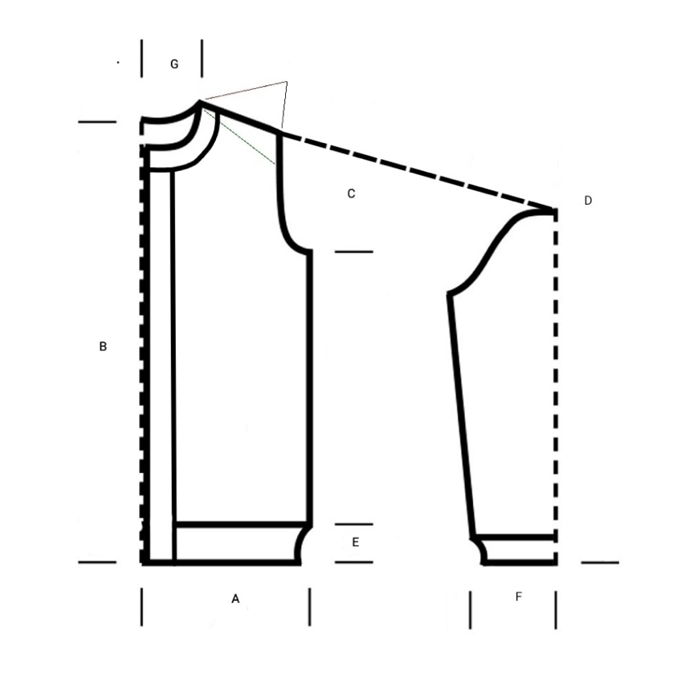
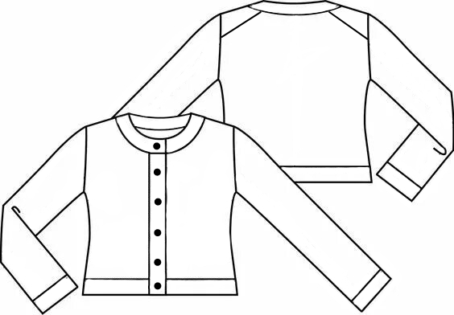
Addition:
Main pattern - stockinette stitch.
When knitting in the round, all stitches in both knit and purl rounds are knitted as knit stitches. When knitting flat, all stitches in knit rows are knitted as knit stitches. In purl rows - as purl stitches.
Important! To facilitate the cast-on for subsequent work with the sleeves and neckline, knit the edge stitches! In knit rows, knit the edge stitches as knit stitches, in purl rows - as purl stitches.
Increases on the slopes and neckline are made from yarn overs, knitted as twisted knit stitches in knit rows and twisted purl stitches in purl rows.
Rubber band 1*1 - alternate 1 k, 1 p to the end of the row.
The elastic 1*1 on the sleeves ends 2 with rows of hollow elastic (1 round – k remove (thread in work), p 2 round - k knit with a knit stitch, p remove (thread before work).
The elastic for the bottom of the product and strips 1*1 ends with a hollow elastic (1 and 2 round – k remove (thread in work), p.).
The loops are closed using a needle.

Symbols:
k – face loop
p – Purl stitch
r. - round
2VмЛЛ – knit the loops together with a left-leaning twist.
2VmLP – 2 knit the stitches together through the front with a right-leaning twist.
krom. – edge stitch
PrLL – increase 1 k with a left-leaning twist from the yarn over
PrLP – increase 1 k with a right-leaning twist from the yarn over
PrIP – increase 1 p with a right-leaning twist from the yarn over
ПрИЛ – прибавить 1 изн. с наклоном влево из протяжки.
НПР – нить перед работой
НЗР – нить за работой
Ход работы:
Back.
Набрать 26(28)30(32)34(34) петли (включая кромочные) обычным способом. Провязать установочный ряд изнаночными петлями.
Скосы.
We begin shaping the shoulder slopes on the back.
1 round (k): 3 k, PrLL, knit k all stitches until there are 3 stitches left on the needle, PrLP, 3 k.
2 round (p): 3 p, PrIP, knit p all stitches until there are 3 stitches left on the needle, PrIL, 3 p.
In total, make 24/25/28/31/34/38 increases on each side. For size XS, knit the last p round without changes. After all increases, there will be 74/78/86/94/102/110 sts on the needles. The slopes are finished.

Armholes.
Let's start knitting the armholes.
To start, knit in stockinette stitch 18/20/22/22/22/22 rows.
Next, we proceed to the increases.
1 group of increases:
1 round (k): 3 k, PrLL, knit all stitches until there are 3 stitches left on the needle, PrLP, 3 k.
2 round (p) - all p loops.
3 round – all k.
4 round – all p.
The number of stitches on the needles 76/80/88/96/104/112
1 group of increases:
5 row – like 1-th
5 row – like 1-th
5 row – like 1-th
5 row – like 1-th
Number of stitches on the needles 80/84/92/100/108/116.
1 group of increases:
Increase by 1 stitch on both sides in each row.
1 round (k): 3 k, PrLL, knit k all stitches until there are 3 stitches left on the needle, PrLP, 3 k.
10 row (p): 3 p., PmI, knit p all stitches until there are 3 stitches left on the needle, PmL, 3 p.
Then repeat rows 9 and 10 1 more times for sizes XS, S, M – a total of 12 rows and 2 times for sizes L, XL, XXL – a total of 14 rows.
On the needles 88/92/100/112/120/128 the upper part of the back is ready, cut the working yarn.
Front.
Right side of the front.
Start knitting from a new ball of yarn. Position the back with the right side facing you and pick up stitches along the slope from the armhole to the neckline (from right to left). Pick up 1 stitch from each row + 1 stitch from the straight part of the armhole. Total: 24/25/29/32/35/38 p.
Setup row (wrong side) – knit all stitches purl.
1 row (right): 3 k, 2P1L, then knit all stitches k.
2 row (wrong): knit all stitches p.
3 row: knit all stitches k.
4 row: knit all stitches p.
Repeat rows from 1 to 4-th 3 times for all sizes (total 16 rows), on needles 20/21/25/28/31/34 stitches.
Next, we begin to shape the neckline.
17 row (k): 3 k., 2VnLL, then knit all stitches k until there are 3 stitches left on the left needle, PnP, 3 k.
2 row (wrong): knit all stitches p.
19 row (k): all stitches k until there are 3 stitches left on the left needle, PnP, 3 k.
2 row (wrong): knit all stitches p.
Repeat rows from 17 to 20-th one more time. Total 24 r.
On the needles 22/23/27/30/33/36 st.
25 row (k.): 3 k., 2VnLL, then knit all stitches k until there are 3 stitches left on the left needle, PnP, 3 k.
26 row (p.): 3 p., PnI, then all stitches p. to the end of the row.
27 row (k.) all stitches k until there are 3 stitches left on the left needle, PnP, 3 k.
26 row (p.): 3 p., PnI, then all stitches p. to the end of the row.
5 row – like 1-th
5 row – like 1-th
Repeat rows from 29 to 30-th one more time for sizes XS, S, M and 2 times for sizes L, XL, XXL.
Total 32/32/32/34/34/34 row. On the needles 29/30/34/39/42/45 stitches.

На 33/33/33/35/35/35 ряду провязать все петли лицевыми, пока на спицах не останется 3 п., сделать прибавку из протяжки с наклоном вправо, 3 лиц., набрать 8/8/9/9/10/10 воздушных петель с помощью доп. нити (этот ряд считать первым). Далее ещё 17(19)21(21)21(21) р → всего провязать по прямой всего 18/20/22/22/22/22 р.
On the needles 38/39/44/49/53/56 stitches.

Next, make increases similar to the increases at the armhole of the back.
1 group of increases:
1 row (k): 3 k, increase, knit k all stitches until the end of the row
2 row (p) - all stitches p.
3 round – all k.
4 round – all p.
Number of stitches on the needles 39/40/45/50/54/57 st.
1 group of increases:
5 row – like 1-th
5 row – like 1-th
5 row – like 1-th
5 row – like 1-th
Number of stitches on the needles 39/40/45/50/54/57 st.
1 group of increases:
Add one stitch in each row.
9 round (k.): 3 k., PrLL, knit k all stitches to the end of the round.
10 round (p.): knit all stitches p until there are 3 st. left on the needles, PrIP, 3 p.
Next, repeat rounds 9 and 10 1 more times for all sizes XS, S, M – a total of 12 rounds and 2 times for sizes L, XL, XXL – a total of 14 rounds.
Number of stitches on the needles 39/40/45/50/54/57 st.
Cut the working yarn.
Left side of the front.
We start knitting from a new skein. Position the back side with the right side facing you and pick up stitches along the slope from the neckline to the armhole (from right to left). From each row, pick up 1 stitch + 1 stitch from the straight part of the armhole. In total: 24/25/29/32/35/38 st.
Setup round (purl side) - knit all stitches purl.
Next, we will make decreases.
1 row (k): knit all stitches until there are 5 stitches left on the needles, 2 k2tog, 3 k.
2 row (p): purl all stitches.
3 row: knit all stitches k.
4 row: knit all stitches p.
Repeat rows from 1 to 4-th 3 times for all sizes (total 16 rows), on needles 20/21/25/28/31/34 stitches.
Next, we begin to shape the neckline.
17 row (k): 3 k, k2tog, then knit all stitches until there are 5 st. left on the left needle, 2 k2tog, 3 k.
2 row (p): purl all stitches.
19 row (k): 3 k, k2tog, all other stitches k.
2 row (p): purl all stitches.
Repeat rows from 17 to 20-th one more time. Total 24 r. On the needles 22/23/27/30/33/36 st.
17 row (k): 3 k, k2tog, then knit all stitches until there are 5 st. left on the left needle, 2 k2tog, 3 k.
26 row (p): all stitches p until there are 3 st. left on the needles, P1L, 3 p.
27 row (k) 3 k, P1L, all stitches k to the end of the row
28 row (p): all stitches p until there are 3 st. left, P1L, 3 p.
5 row – like 1-th
5 row – like 1-th
Repeat rows from 29 to 30-th one more time for sizes XS, S, M and 2 times for sizes L, XL, XXL. Total 32/32/32/34/34/34 r. On the needles 29/30/34/39/42/45 stitches.
На 32/32/32/34/34/34 р. в конце ряда набрать 8/8/9/9/10/10 воздушных петель с помощью доп. нити. На 33/33/33/35/35/35 р. провязать набранные воздушные петли лиц., 3 лиц., ПрЛЛ, все оставшиеся петли лиц. (этот ряд считать первым).
Next, another 17(19)21(21)21(21) r → total knit straight 18/20/22/22/22/22 r.
On the needles 38/39/44/49/53/56 stitches.
Next, make increases similar to the increases at the armhole of the back.
1 group of increases:
1 row (k): 3 k, increase, knit k all stitches until the end of the row
2 row (p) - all stitches p.
3 round – all k.
4 round – all p.
Number of stitches on the needles 39/40/45/50/54/57 st.
1 group of increases:
5 row – like 1-th
5 row – like 1-th
5 row – like 1-th
5 row – like 1-th
Number of stitches on the needles 39/40/45/50/54/57 st.
1 group of increases:
Add one stitch in each row.
9 round (k.): 3 k., PrLL, knit k all stitches to the end of the round.
10 round (p.): knit all stitches p until there are 3 st. left on the needles, PrIP, 3 p.
Next, repeat rounds 9 and 10 1 more times for all sizes XS, S, M – a total of 12 rounds and 2 times for sizes L, XL, XXL – a total of 14 rounds.
Number of stitches on the needles 39/40/45/50/54/57 st.
Do not cut the working yarn.
Connection of the shelves and the back.
Knit the edge stitches as knit stitches in the right side rows and as purl stitches in the wrong side rows.
1 round: Knit the stitches of the left front k, cast on 4/4/6/6/8/8 chain stitches, knit the stitches of the back, then cast on 4/4/6/6/8/8 chain stitches for the next underarm and the stitches of the right front. In the middle of the stitches of both underarms, place markers (consider this round as the first).
Number of stitches on the needles 39/40/45/50/54/57 st.
Knit in back-and-forth rounds with 2 - 6 round.
Make decreases in 7-m on both sides of the stitch markers as follows: knit stitches of the left front, not knitting 3 stitches to the stitch marker at the middle of the first underarm, 2k, 1 knit, stitch marker, 1 knit, 2k, knit stitches of the back not knitting 3 stitches to the stitch marker at the middle of the second underarm, 2k, 1 knit, stitch marker, 1 knit, 2k, knit to the end of the row.
Сделать еще 2/2/3/3/4/4 убавки в каждом 11-м р. (лицевом ряду).
*The round in which the first decreases are made is considered the 1st. Thus, the following decreases should be made in the 2nd, 3rd, 4th, etc. rounds.
Number of stitches on the needles 39/40/45/50/54/57 st.
Knit a total of 65(67)72(73)75(75) rounds. Change the needles to 4 mm. Knit in ribbing 1*1 17 rounds and 2 r. in hollow ribbing (1 and 2 round – k slip (yarn in back), p.).
Close the stitches with a needle.

Sleeves.
Attach a new yarn in the center of the underarm, and with needles begin to pick up stitches with the main needle size (4.50 mm): from the underarm stitches 2/2/3/3/4/4 stitches. Then follow the main rhythm of picking up stitches: from four rows, pick up 3 stitches (3 stitches to pick up, 1 to skip).
A total of 78/80/84/88/92/96 stitches on the needles.
Shape the sleeve cap using short rows with a step of 2 stitches. You can use any method that is comfortable for you, for example, the German method of short rows.
Video German method of short rows:
https://youtu.be/z-E3YSHPQYs?si=5xvmYK0-iF1ek3Wl
During the knitting of the first short row, divide the stitches into two parts, marking the beginning of the row (at the center of the underarm) and the middle of the sleeve cap with stitch markers: from the beginning of the row marker, count 39/40/42/44/46/48 stitches to the top of the sleeve marker, 39/40/42/44/46/48 p.
Укороченный ряд 1 (лиц.): МНР, 39/40/42/44/46/48 лиц., поставить маркер вершины, 16/16/17/18/19/20 лиц., развернуть вязание на изнаночную сторону.
Укороченный ряд 2 (изн.): снять петлю, натянуть нить назад до появления «ножек», вязать в обратную сторону до маркера вершины плеча, переснять маркер, 16/16/17/18/19/20 изн., развернуть вязание на лицевую сторону.
Укороченный ряд 3 (лиц.): снять петлю, натянуть нить вперед до появления «ножек», вязать лиц. до маркера вершины, 15/15/16/17/18/19 лиц., провязать «ножки», 2 лиц., развернуть вязание.
Укороченный ряд 4 (изн.): снять петлю, натянуть нить назад до появления «ножек», вязать в обратную сторону до противоположных «ножек», провязать их как 1 изнаночную, 2 изн., развернуть вязание.
Then continue knitting with turns, adding 2 stitches each time, until there are 1-2 stitches left on the needles to the beginning marker. After that, switch to circular knitting.
Transition from flat knitting to circular:
Knit 6 rounds in the round with knit stitches. Then a round with decreases.
Ряд с убавками: МНР переснять, 1 лиц., 2ВмЛП, вяжем лиц., пока перед маркером не останется 3 петли, 2ВмЛЛ, 1 лиц. Всего убавили 2 петли.
Next, knit the rows in the round with the right side facing. Make decreases.
Decreases continue to be made in every 8-th round. Knit to the required length, finish with ribbing 15 r., 2 r. with hollow ribbing, close stitches with a needle.

Knit the second sleeve in the same way.

The neck edging.
Cast on stitches on needles 4 mm. The knitting is positioned towards you with the right side facing. From the chain of air stitches of the left front piece, cast on at the 1-th stitch (8/8/9/9/10/10), then from the left front piece, pick up stitches with a step of 3/1 (3 stitches to be picked up, 1 stitch to be skipped), from the back – from each stitch. From the right front piece, we pick up stitches with a step of 3/1.
The total number of stitches must be odd.
Video of lifting stitches with a step/skipping stitches:
https://youtu.be/z-E3YSHPQYs?si=5xvmYK0-iF1ek3Wl
Knit the setup p round: knit the edge stitches as p in p rounds and edge stitches as knit stitches in knit rounds. P round: edge stitch, then knit an odd number of stitches in ribbing 1*1, edge stitch. Knit ribbing 1*1 for another 7 rounds. Then we knit 2 setup rounds in hollow ribbing before closing with a needle. The last 10 round – closing with a needle.

Планки.
Пуговицы будут располагаться на левой полочки, отверстия для пуговиц на правой.
Работа выполняется снизу от края кардигана поднимаясь вверх к горловине. Поднимайте по 1 петле на каждый ряд (как показано на картинке или видео). Необходимо, чтобы количество рядов кардигана и планки совпадало.
Видео поднятия петель планки: https://youtu.be/TaqZfZJNoCw?si=ZK7g_E8L-T5RaNmL
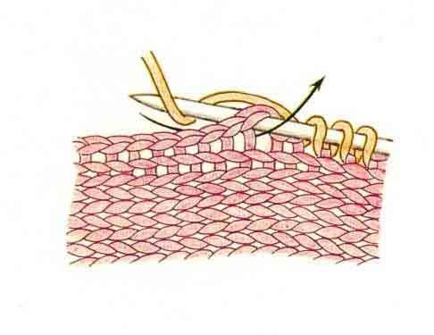
Ход работы:
На спицы 4 мм с длинной леской поднять по 1 п из каждой петли по краю левой полочки.
The final number of stitches will depend on the length of the cardigan.
Cut the thread leaving 10-15 cm.
Before starting work, mark the locations of 5 stitches with markers.
the left side of the front. The lower button should be located 3.5-4 cm from the edge of the ribbing, and the upper button should be located 3 cm from the edge of the neckline. Place the remaining markers
so that there is equal spacing between the buttons. You will find the description of the buttonholes below.
Join the yarn and cast on 15 new stitches on the same needle as the stitches along the edges of the shelves,
using the Italian cast-on method. In this case, the first and last stitches of the cast-on will be purl.

The front band is knitted in back-and-forth rows with a double ribbing, with the last of the <ph id="PH001" /> stitches in the knit rows
being knitted together with the corresponding stitch from the cast-on.
вдоль края полочки. Для вязания планки используется дополнительная чулочная спица.
Вяжем планку на правой полочке:
1. Разверните вязание на изнаночную сторону, спица в правой руке, на нее набираем 15 петель итальянским способом.
2. Разворачиваем вязание на лицевую сторону. Возьмите дополнительную спицу.
3. 1 ряд (лицевой): *1 лиц, 1 петлю снять НПР*, чередуйте так пока на левой спице не останется 1 петля. Провяжите ее вместе с ранее поднятой петлей на планке лицевой петлей, разверните вязание на изнаночную сторону.
4. 2 ряд (изнаночный): петлю снять НПР, *1 лиц, 1 петлю снять НПР* последнюю петлю в этом ряду снять не провязывая НПР. Развернуть вязание на лицевую сторону.
5. Повторяйте чередовать пункт 3 и 4 до конца полочки. Не забывайте, что на правой полочке мы делаем отверстия для пуговиц.
6. Закрыть петли с лиц. стороны, используя итальянский способ. Когда останутся 2 последние петли (провяжите их вместе
лицевой за заднюю стенку).
Вяжем планку на левой полочке:
1. Вязание на лицевой стороне. На правую спицу наберите 15 петель итальянским способом.
2. Разворачиваем вязание на изнаночную сторону. Возьмите дополнительную спицу.
3. 1 ряд (изнаночный): * 1лиц, 1 петлю снять НПР*, *, чередуйте так пока на левой спице не останется 1 петля. Провяжите ее вместе с ранее поднятой петлей на планке изнаночной петлей, разверните вязание на лицевую сторону.
4. 2 ряд (лицевой): петлю снять НЗР, *1 лиц, 1 петлю снять НПР*, последнюю петлю в этом ряду снять не провязывая НПР. Развернуть вязание на изнаночную сторону.
5. Чередуйте пункт 3 и 4 до конца полочки. На левой планке отверстий для пуговиц нет. Вяжем до конца полочки.
6. Закрыть петли с лиц. стороны, используя итальянский способ. Когда останутся 2 последние петли (провяжите их вместе
лицевой за заднюю стенку).
Видео набора петель итальянским способом и вывязывание планки: https://www.youtube.com/watch?v=yQkI9K2WhKI

Buttonholes.
Buttonholes are formed by dividing the fabric of the band into two parts and knitting these sides separately
these sides (see video https://www.youtube.com/watch?v=Ir28MBj0qJk). Starting work on the loop – at the point where you previously placed the Stitch marker.
Разделите планку на 2 части: 1 часть = 8 петель, 2 часть = 7 петель.
Вяжем 1 часть:
1. p (knit): * 1 k, 1 slip stitch purlwise *, repeat * - * 4 times. Turn the work.
2. p (purl): * 1 k, 1 slip stitch purlwise *, repeat * - * 4 times. Turn the work.
Repeat 1 - 2 rows 3 times (i.e. knit a total of 6 rows). If you want to make the stitches larger, knit 8 rows.
Далее провязать лицевой ряд еще раз, так чтобы рабочая нить была посередине петель планки. Отрезать нить.
Теперь связать 2 часть планки на оставшихся 7 петлях.
Присоединить новую нить и вязать 2 часть планки:
1. p (knit): * 1 k, 1 slip stitch purlwise *, repeat from * to * 3 times. Knit 2 together with the knit stitch (i.e. the last of 7 stitches from the column and the lifted stitch from the front). Turn the work to the purl side.
2. p (purl): *slip 1 stitch purlwise, 1 k *, repeat from * to *,
the last stitch in this row is slipped without knitting purlwise. Turn the work to the knit side.
Repeat 1 - 2 rows 3 times (a total of 6 rows have been knitted).
Knit 1 row (knit) once more connecting the edge stitches with the lifted stitches from the front. The next row will be purl, where we will close the buttonhole and continue knitting the edge.
Joining the parts of the edge:
1. p (purl): * slip 1 stitch purlwise, 1 k *, repeat from * to *, the last stitch in this row is slipped without knitting purlwise. Turn the work.
1 buttonhole stitch is ready, the next row is knit.
The end of the yarn remains at the top of the stitch, it needs to be carefully woven in inside the knitting.
Video of buttonholes: https://www.youtube.com/watch?v=Ir28MBj0qJk

